1.02 Design an Infographic
Step 1: Choose a Topic
Using the internet, collect data or information about a growing community, school, or global concern. You may wish to review some of the topics at the following websites:
Global Issues http://www.globalissues.org/
Educational Issues http://www.education.com/topic/current-education-issues/
Fun Infographics http://easel.ly

Step 2: Learn More About Infographics
Optional Resources:
- Free downloadable images can be found at www.iconarchive.com.
- 10 Tips for creating an Infographic

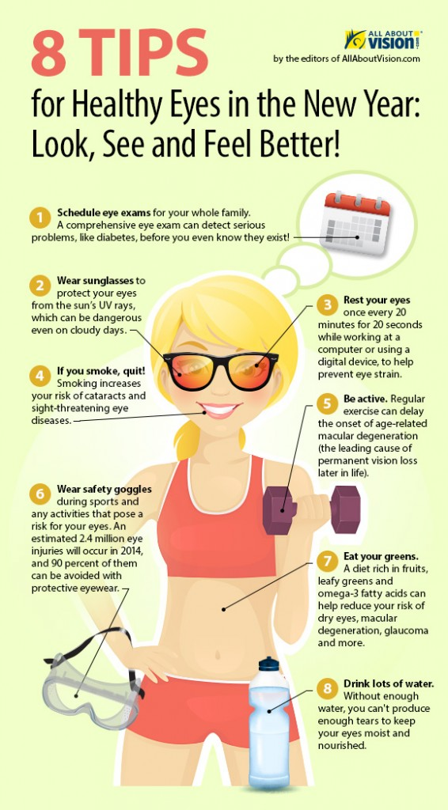
Ideas for infographic formats include:
- Timelines
- Flow charts
- Annotated maps or graphics
- Graphs
- Venn diagrams
- Size comparisons

Step 3: Design Your Infographic
Using desktop publishing software, create an 8 ½” x 11” infographic related to your topic.
Your Infographic will be posted in the school to raise awareness of your chosen issue. You may also choose a musician, sports, etc. You must research your topic.
All information must be current and all sources must be listed. Do not use Wikipedia or other websites that do not have proven information.

